GET Requests:

1. с использованием фильтрации

[https://212.98.189.156:12490/jetCloud/apps/zjblessons/jblesson02/v01/01.xsodata/zjblessons_base_Headers?$filter=CreatedByFullName eq 'Nana Nebieridze'](https://212.98.189.156:12490/jetCloud/apps/zjblessons/jblesson02/v01/01.xsodata/zjblessons_base_Headers?$filter=CreatedByFullName)

1. с выборкой 2-х полей

[https://212.98.189.156:12490/jetCloud/apps/zjblessons/jblesson02/v01/01.xsodata/zjblessons_base_Headers?$select=HeaderID, DocumentNumber](https://212.98.189.156:12490/jetCloud/apps/zjblessons/jblesson02/v01/01.xsodata/zjblessons_base_Headers?$select=HeaderID,)

1. с пропуском 10 записей из таблицы

<https://212.98.189.156:12490/jetCloud/apps/zjblessons/jblesson02/v01/01.xsodata/zjblessons_base_Headers?$top=10>

POST Request:

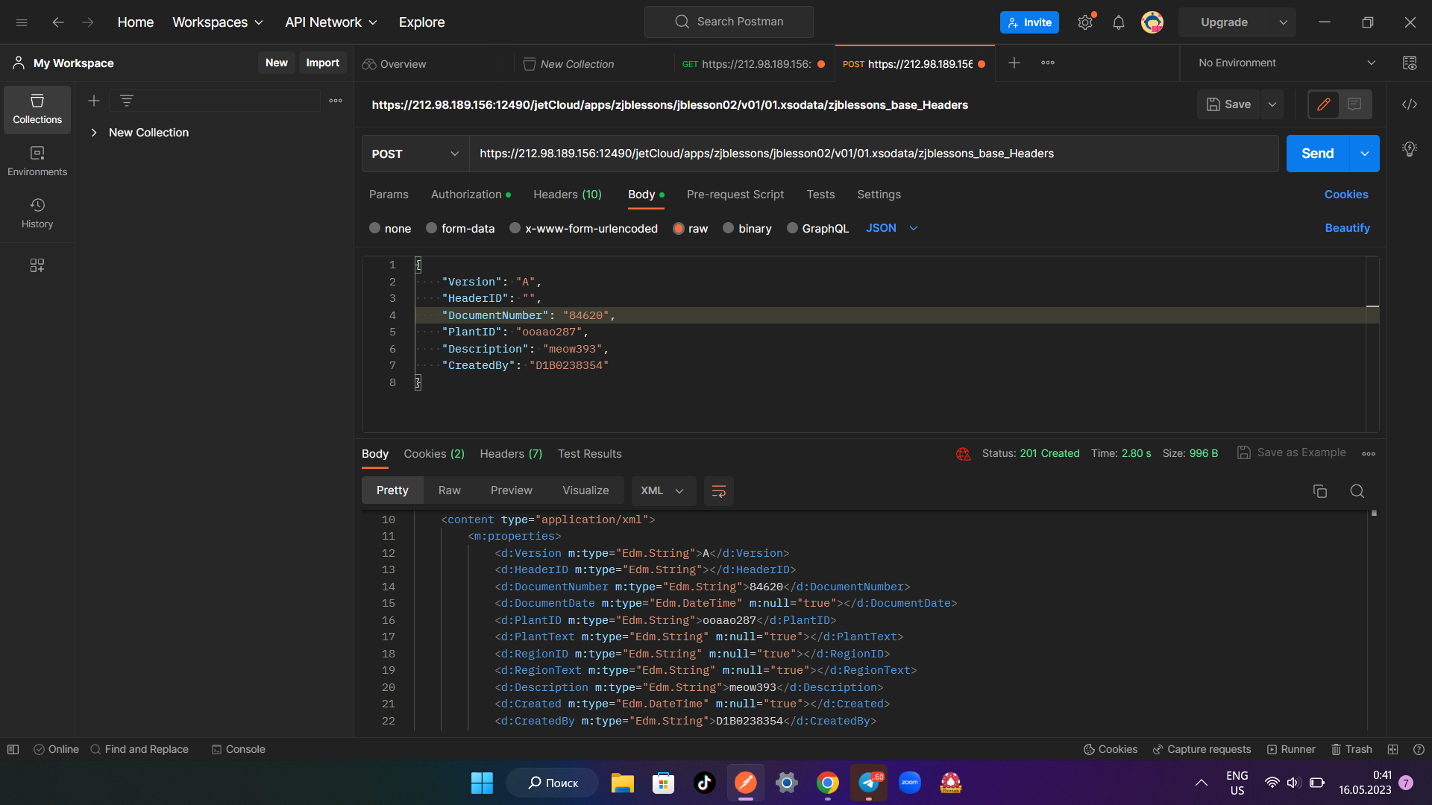

MERGE Request:

